**MOVEABLE 2 TYRES INDUSTRIAL FANS:**

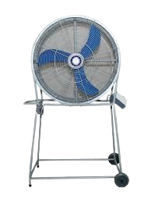

**Price: 26,500.00**

The Moveable Two-Tyre Industrial Fan is a versatile and portable ventilation solution, designed for easy relocation and flexibility in demanding industrial environments. With its sturdy two-tyre design, this fan can be effortlessly moved to different areas, providing powerful airflow and intense air circulation wherever needed. Its heavy-duty construction, adjustable speed settings, and durable components ensure reliable operation, making it an ideal choice for factories, warehouses, and manufacturing facilities that require flexible and mobile ventilation solutions.

**Key features of moveable 2 tyres industrial fans include:**

* **Portability** – Equipped with two tires for easy movement.
* **High Airflow** – Delivers strong, efficient airflow for various applications.
* **Durability** – Built to withstand harsh environments.
* **Adjustable Speed** – Offers variable airflow settings.
* **Stability** – Stable design for secure operation during use.
* **Energy Efficiency** – Designed to minimize power consumption.
* **Rugged Construction** – Made from durable materials for long-lasting performance.